**Practical 2**

**Aim:**

**Displaying different LED patterns with Raspberry Pi.**

**Additional Hardware required:**

1. Resistors
2. LEDs
3. Jumper wires
4. Breadboard

**Connections:**

1. Connect LEDs on breadboard
2. Connect resistor to one end of led (to Positive end or anode).
3. Connect other end of resistor to GPIO pin on raspberry Pi.
4. Connect other end of LED to ground (negative end or cathode).

**GPIO Pinout Diagram:**

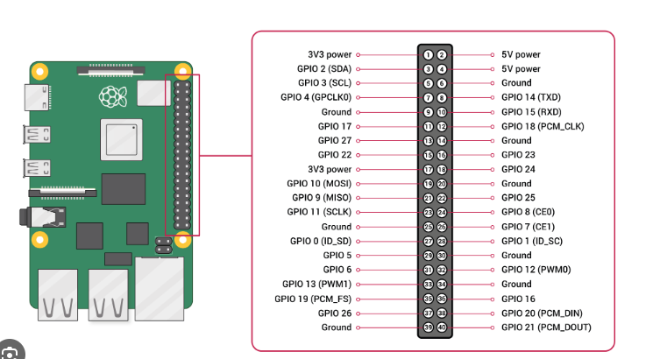

**Write following code in Python IDLE 3 save it as ‘pattern.py’**

**Note: Before starting the first program it is advisible to install IDLE for this use below command:**

**sudo apt install idle3**

**Program:**

import RPi.GPIO as GPIOfrom time import sleep

GPIO.setmode(GPIO.BOARD)

led1=29 #Yellowled2=31 #Green

GPIO.setup(led1,GPIO.OUT)GPIO.setup(led2,GPIO.OUT)

GPIO.output(led1,False)GPIO.output(led2,False)

def ledpattern(v1,v2): GPIO.output(led1,v1) GPIO.output(led2,v2)

try: while True: ledpattern(1,0) sleep(0.5) ledpattern(0,1) sleep(0.5) ledpattern(1,1) sleep(0.5) ledpattern(0,0) sleep(0.5)finally: GPIO.output(led1,False)

GPIO.output(led2,False) GPIO.cleanup()